DATES | 9.30-120:00 | 10.00-12.30 | 10.00AM |  | 12.30-3.00 PM  NEW BATCH |  |  | 1.00PM |  | NEW BATCH  2.30-5.00  OCT -6 |  |  | 3.00-5.30 |  | 3.00-5.30
MON  29/09 | 9.30-.10.30  ENGLISH  10.30-12.00  QUANT | 10.00-11.30  REASONING  11.30-12:30  ENGLISH | 10.00-11.30  G.K-102  11.30-12.30  PUNJABI |  | 12.30-1.30  QUANT  1.30-3.00  G.K-11 |  |  | 12.30-1.30  QUANT  1.30-3.00  G.K-11 |  | NEW BATCH  2.30-5.00  OCT -6 |  |  | 3.00-4.30  REASONING  4.30-5.30  COMPUTER |  | 3.00-4.30  REASONING  4.30-5.30  COMPUTER
TUE  30/09 | 9.30-11.00  REASONING  11.00-12.00  COMPUTER | 10.00-11.30  QUANT  11.30-12.30  G.K-31 | 10.00-11.30  G.K-103  11.30-12.30  ENGLISH |  | 12.30-2.00  REASONING  2.00-3.00  ENGLISH |  |  | 12.30-2.00  REASONING  2.00-3.00  ENGLISH |  | NEW BATCH  2.30-5.00  OCT -6 |  |  |  | 3.00-4.30  G.K-33  4.30-5.30  QUANT | 3.00-4.30  G.K-33  4.30-5.30  QUANT
WED  01/10 | 9.30-11.00  G.K-50  11.00-12.00  QUANT | 10.00-11.30  REASONING  11.30-12.30  COMPUTER | 10.00-11.00  ENGLISH  11.00-12.30  G.K-104 |  | 12.30-2.00  QUANT  2.00-3.00  COMPUTER |  |  | 12.30-2.00  QUANT  2.00-3.00  COMPUTER |  | NEW BATCH  2.30-5.00  OCT -6 |  |  | 3.00-4.30  REASONING  4.30-5.30  PUNJABI |  | 3.00-4.30  REASONING  4.30-5.30  PUNJABI
THUR  02/10 | HAPPY DUSSEHRA 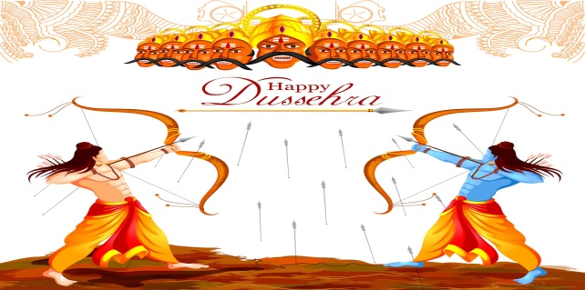 HAPPY DUSSEHRA
FRI  03/10 | 9.30-11.00  REASONING  11.00-12.00  ENGLISH | 10.00-11.00  ENGLISH  11.00-12.30  QUANT |  | 10.00-11.30  G.K-105  11.30-12.30  PUNJABI |  | 12.30-2.00  REASONING  2.00-3.00  ENGLISH |  |  | 12.30-2.00  REASONING  2.00-3.00  ENGLISH |  |  | NEW BATCH  2.30-5.00  OCT -6 |  | 3.00-4.30  G.K-34  4.30-5.30  QUANT |  | 3.00-4.30  G.K-34  4.30-5.30  QUANT
SAT  04/10 | 9.30-11.00  G.K-49  11.00-12.00  QUANT | 10.00-11.00  COMPUTER  11.00-12.30  REASONING |  | 10.00-11.00  REASON ING  11.00-12.30  G.K-106 |  |  | 12.30-1.30  QUANT  1.30-3.00  G.K-12  REVISION CLASSS-3.00-3.30  COMPUTER | 12.30-1.30  QUANT  1.30-3.00  G.K-12 |  |  | NEW BATCH  2.30-5.00  OCT -6 |  | 3.00-4.00  ENGLISH  4.00-5.30  REASONING |  | 3.00-4.00  ENGLISH  4.00-5.30  REASONING

